Zombies Vs Tank

Submitted in partial fulfilment of the requirements

of the degree of

Bachelor of Engineering in Artificial Intelligence and Data Science

by

Priyanshu Singh (53)

Deepak Prasad (44)

Tejas Patne (41)

Sneha Kadambala (23)

under the guidance of Supervisor (s):

Sangeeta Oswal



**Department of Artificial Intelligence and Data Science**

**Vivekanand Education Society’s Institute of Technology**

**2021-2022**

**Department of Artificial Intelligence and Data Science**

# CERTIFICATE

This is to certify that **Priyanshu Singh, Deepak Prasad, Tejas Patne, Sneha Kadambala** of Second Year of Artificial Intelligence and Data Science studying under the University of Mumbai have satisfactorily presented the Mini Project entitled **Zombie Vs Tank** as a part of the MINI-PROJECT for Semester-IV under the guidance of **Mrs.** **Sangeeta Oswal** in the year 2021-2022.

Date:03/05/2022



Dr. Mrs. Vijaylakshi Mrs. Sangeeta Oswal

(Name and sign) (Name and sign)

Head of Department Supervisor/Guide

# DECLARATION

We, **Priyanshu Singh, Deepak Prasad, Tejas Patne, Sneha Kadambala** from ***D6AD***, declare that this project represents our ideas in our own words without plagiarism and wherever others' ideas or words have been included, we have adequately cited and referenced the original sources.

We also declare that we have adhered to all principles of academic honesty and integrity and have not misrepresented or fabricated or falsified any idea/data/fact/source in our project work.

We declare that we have maintained a minimum 75% attendance, as per the University of Mumbai norms.

We understand that any violation of the above will be cause for disciplinary action by the Institute.

Yours Faithfully

1. Priyanshu Singh 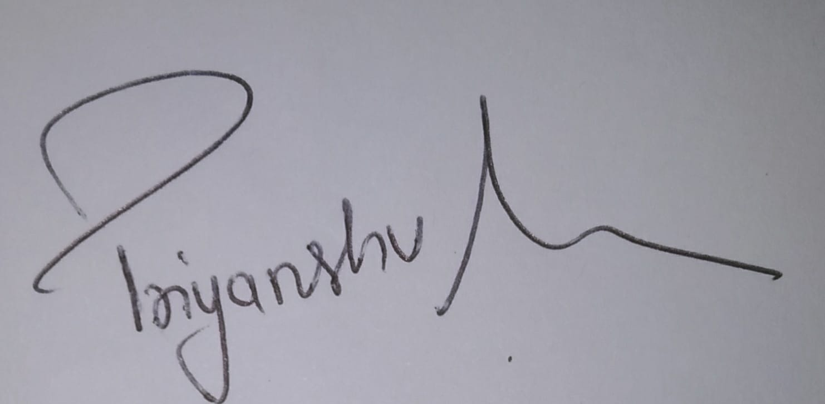

1. Deepak Prasad 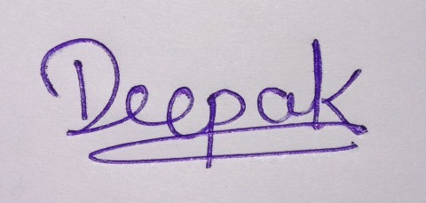

1. Tejas Patne 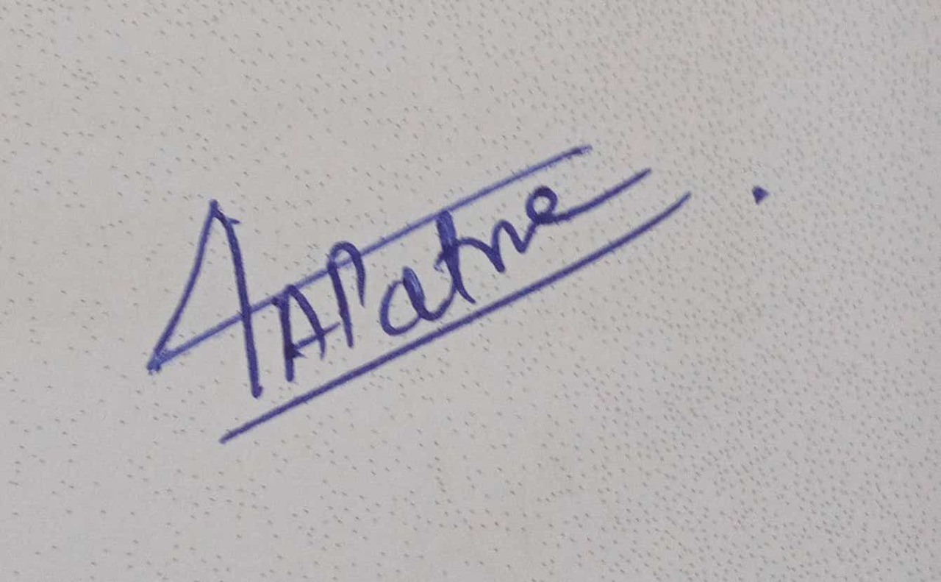

1. Sneha Kadambala 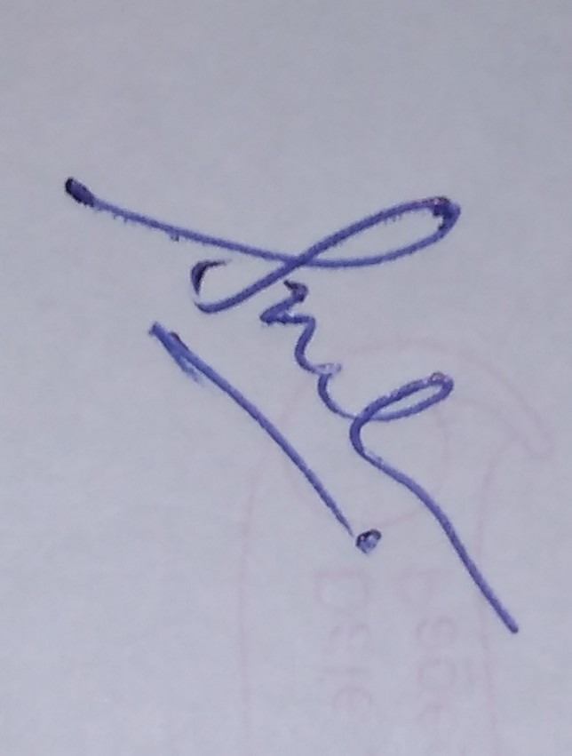

# Acknowledgment

We would like to express our sincere thanks to **Mrs. Sangeeta Oswal**, for his/her valuable guidance and support in completing our project.

We would also like to express our gratitude towards our HOD and Vice-Principal

**Dr. Mrs. M Vijaylakshmi** Madam for giving us this great opportunity to do an AIBased Game Development project on **Zombie vs Tanks**. As the first AI and DS batch of our college, we are thankful to our Department for helping us to start our learning journey with fun AI game Development. Without their support and suggestions, this project would not have been completed.

Table of Contents

**Abstract**

**List of Tables**

**List of Figures**

1. **Introduction** Pg No
   1. Introduction
   2. Problem Statement
   3. Objectives
   4. Scope

1. **Literature Survey**
   1. Literature/Techniques studied
   2. Papers/Findings

1. **Analysis and Design**
   1. Analysis of the system
   2. Proposed Solutions
   3. Design of the proposed system

1. **Results and Discussion**

1. **Conclusion and Future Work**

**References**

# Abstract

Inspired by **Dead Venture: Zombie Survival** game, We have tried to build a Shooting game. In this study, we tried to create a basic structure of a game and a story to implement AI in the game. We have tried to implement Reinforcement Learning for the zombies. For this purpose we have studied Q-learning algorithm in depth. Using this algorithm, zombie will attack on tank(player). With the help of algorithm, he will determine the optimal path towards the tank. Once zombie reaches to tank, the game over is displayed.

# Introduction

Nowadays, shooting games are popular. Zombie survival is one of the crowd -pleasing categories. There are lots of famous 2D as well as 3D Zombie survival games. One of them is Dead Venture: Zombie Survival. Will of humans for survival make these games more engaging. By introducing AI, the gaming ability of players can be improved step by step.

Just like Covid-19 Pandemic, the story of the game starts with the Zombie pandemic. If Zombie baits a normal person then that healthy person also becomes Zombie and does the same. Zombies in our games know only one thing i.e. to bait a normal human and turn him/her into a Zombie. Our user is the only human in the city.

Gameplay:

A player will be given a tank. This tank can fire unlimited shots. The player can kill a Zombie with one shot of canon on a tank. The motive of the player is to keep Zombies away by killing them. For each Zombie kill, the player will be given 2 points. If any Zombie somehow manages to get close enough to tank, then game overs. The score of the player will be displayed whenever the game ends.

# Literature Learning

We learned about reinforcement learning to implement AI in our game. For this we studied about Q learning algorithm. We also tried to implement game on website using JavaScript.

Q-learning is a value-based learning algorithm and focuses on optimizing the value function according to the environment or problem. Q in the Q-learning represents quality with which the model finds its next action improving the quality. The process can be automatic and straightforward.

## Learning Process of Q-Learning

The following example of a game will help you understand the concept of Q-learning:

#### 1. Initialization

Your agent on playing the game for the first time will not include any knowledge. So we will assume the Q table to be zero.

#### 2. Exploration or Exploitation

In this step, your agent will choose anyone from the two possible ways. If the agent exploits, it will collect information from the Q Table, or when the agent explores, it will try to make new ways.

• When your agent works for a higher number for a while, it is essential to exploit.

• When your agent does not have any experience, exploring is essential.

You can handle the adjustments among two conditions, exploration and exploitation, by adding an epsilon. Include the epsilon on the value function. When we start with the model and do not include any information, you should prefer exploration. However, once your model starts adapting to the environment, you need to follow exploitation. In simple words, the agent will take action in step two, and the choices are exploration and exploitation.

#### 3. Measure Reward

When the agent decides what action to choose, it acts. This leads the agent to the next step, which is State “S.”In this state, the agent performs four actions. Each of these actions will direct the agent to various reward scores. For instance, if the agent chooses state five from state 1, it will move further based on that state’s experience. The agent can now choose to move to State 6 or State 9 depending on the previous experience and possible reward expectation.

#### 4. Update Q table

The agent will calculate the reward value. The algorithm will use Bellman’s equation to update the value at State “S.” Here are some terminologies

Learning Rate–Learning rate is a constant that determines the weight you need to add in the Q-Table for generating a new value instead of the old one.

Discount Rate–Discount rate is the constant. It discounts about what will be the future reward. In simple words, discount rate helps in balancing the effect of upcoming rewards on the new values.

Once the agent goes through all these steps learning significantly, it will achieve updated values on Q-Table. Now, it is simple to use the Q-Table as mapping the states. Every state agent will select an action leading it to the state with the highest Q value.

# Paper Findings

***Non-ML Zombie vs Tanks* :**

[https://new.pythonforengineers.com/blog/zombies-vs-tanks-a-simple-game-inpython-and-pygame-zero/](https://new.pythonforengineers.com/blog/zombies-vs-tanks-a-simple-game-in-python-and-pygame-zero/)

From this blog, we learned to create our game without using any ML concept. Referring to this, we created a structure of our game.

***RL Algorithm for Bots*:**

[http://cs229.stanford.edu/proj2016/report/UdagawaLeeNarasimhanFightingZombiesInMinecraftWithDeepReinforcementLearning-report.pdf](http://cs229.stanford.edu/proj2016/report/UdagawaLeeNarasimhan-FightingZombiesInMinecraftWithDeepReinforcementLearning-report.pdf)  <https://www.aaai.org/Papers/AIIDE/2008/AIIDE08-013.pdf>

These articles are most important, As they helped us to understand how to combe deep Q-learning with reinforcement learning to play games by accomplishing difficult tasks. Specifically, the convolutional neural network allowed us to make meaningful predictions for optimal actions even with extremely high numbers of states.

***GA vs RL*:**

[https://medium.com/xrpractices/reinforcement-learning-vs-genetic-algorithm-aifor-simulations-f1f484969c56](https://medium.com/xrpractices/reinforcement-learning-vs-genetic-algorithm-ai-for-simulations-f1f484969c56)

This article helped us to decide which algorithm to choose for AI implementation.

***RL***:

tinyurl.com/drllab1

tinyurl.com/drllab2

# Approach

We formalize the reinforcement learning task as a Markov Decision Process. The agent interacts with an environment by making observations and actions and receiving rewards. At each iteration, the agent selects an action from the action space, A = 1, . . . , K. This action then changes the agent’s state and the agent receives rewards based on its new state. The reward indirectly depends not only on the new state it just entered but the entire sequence of actions and observations it made until it entered the new state. Thus, to make an appropriate action in the new state, the agent needs information from previous actions and observations as well as the current observation. We, therefore, consider sequences of actions and observations st = x1, a1, x2, ..., at−1, xt, where xt is the pixel values of the visual input from the agent at time t. All such sequences are finite; thus we now have a finite Markov decision process (MDP), where we use the sequence st as a distinct state at each time-step t.

# GUI

We will try to create our game somewhat similar to shown below

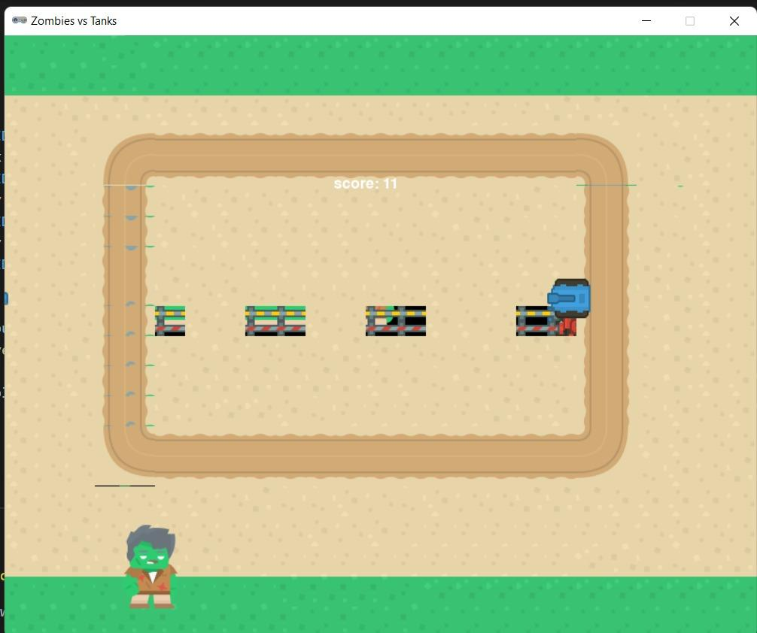GUI Part of the game

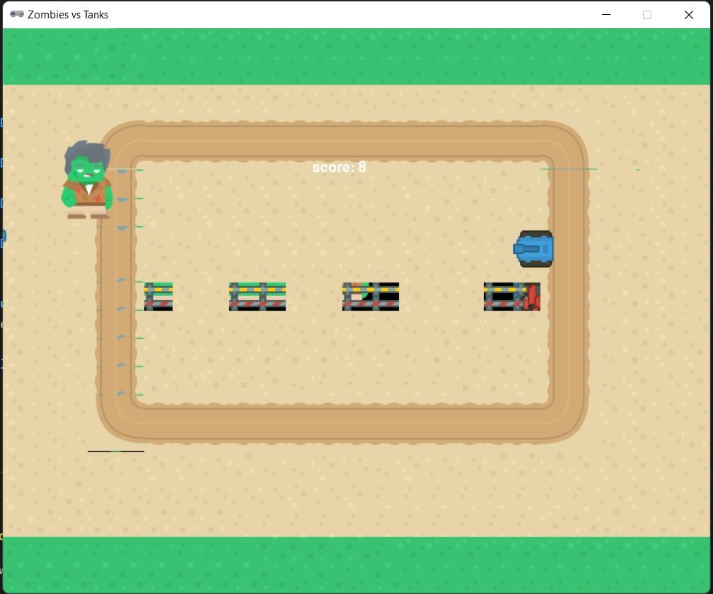

Zombie entering in the game at random position and follows an optimal path to reach the tank using Q-learning

We will also try to create a health bar for player. Also, we will try to create and display a health bar of AI Zombies whenever Zombie gets a shot from the player tank. Unlike normal Zombies, we don’t want AI Zombies to die in only one hit.

# Result and Discussion

In this semester, we have partially implemented our game. We have implemented this game with the Non-ML approach by giving basic information like the position of the tank to Zombies. Then the instruction was given to Zombies to approach the tank according to their positions. To make the moments of Zombies random, we learned how to implement ML in the game. We decided to use a Reinforcement algorithm to improve the performance of random Zombies.

# Conclusion and Future work

In this semester, we learned about Reinforcement learning. So that we can implement it in our game. Also tried to deploy it on the website.

Future Work:

1. Have an Opening Screen
2. To implement AI for uncertain movements of Zombies
3. To increase the difficulty of the game with the performance of player using AI
4. To add Restart function and main menu in the game